✈ AIRLINE FLIGHT PRICE ANALYSIS
Professional Data Analysis Report
EDA • Microsoft Excel • Power BI • Tableau

Project Report
Prepared from the submitted EDA notebook and dashboard outputs

Project Area | Details
Dataset | Airline Flight Price Analysis Dataset
Records | 300,153 flight records
Variables | 12 columns
Analysis Tools | Python (Pandas, NumPy, Matplotlib, Seaborn), Excel, Power BI, Tableau
Primary KPIs | Total Flights, Average Ticket Price, Maximum Ticket Price, Minimum Ticket Price, Average Flight Duration

1. Executive Summary
This project presents an end-to-end analysis of airline flight prices using four complementary analytical stages: Exploratory Data Analysis (EDA) in Python, dashboard analysis in Microsoft Excel, interactive reporting in Power BI, and visual analytics in Tableau. The objective is to understand the structure of the flight dataset, examine pricing patterns, compare airline and route-related characteristics, and communicate the results through business-friendly dashboards.
The submitted EDA notebook contains 300,153 records and 12 variables. The dataset has no missing values and no duplicate records according to the notebook checks. The analysis covers airline, flight, source city, departure time, stops, arrival time, destination city, class, duration, days left, and price.
The dashboard outputs consistently highlight five core KPIs: 300,153 total flights, an average ticket price of approximately 20,890, a maximum ticket price of 123,071, a minimum ticket price of 1,105, and an average flight duration of approximately 12.22 hours.
Across the visual outputs, Vistara has the largest number of flight records, followed by Air India and Indigo. Economy-class records form the larger share of the dataset, while Business-class records represent a smaller share. One-stop flights dominate the stops distribution. The dashboards also show meaningful differences in average price across airlines and clear variation in flight volume across departure-time categories.

2. Project Objectives
- Understand the structure and quality of the airline flight-price dataset.
- Perform exploratory data analysis to identify distributions, patterns, and relationships.
- Analyze flight volume by airline, source city, destination city, departure time, stops, and class.
- Analyze ticket-price patterns using descriptive statistics and dashboard KPIs.
- Examine the relationship between flight duration, days left, and ticket price.
- Build business-friendly dashboards in Excel, Power BI, and Tableau.
- Present the same dataset through multiple analytical tools to improve interpretation and communication.

3. Dataset Overview
The submitted EDA notebook loads an airline flight-price dataset and performs structural, statistical, quality, categorical, and visual analysis. The notebook reports 300,153 observations across 12 columns.
Column | Type in EDA | Description
index | int64 | Record/index identifier
airline | object | Airline name
flight | object | Flight identifier
source_city | object | Origin/source city
departure_time | object | Departure-time category
stops | object | Number of stops category
arrival_time | object | Arrival-time category
destination_city | object | Destination city
class | object | Travel class
duration | float64 | Flight duration in hours
days_left | int64 | Days remaining before departure
price | int64 | Ticket price

3.1 Key Dataset Statistics
Metric | Value
Number of records | 300,153
Number of columns | 12
Average duration | 12.221 hours
Minimum duration | 0.83 hours
Maximum duration | 49.83 hours
Average days left | 26.005 days
Minimum days left | 1 day
Maximum days left | 49 days
Average ticket price | 20,889.66
Minimum ticket price | 1,105
Maximum ticket price | 123,071
Missing values | 0 across all columns
Duplicate rows | 0

4. Methodology
The project follows a four-stage workflow. First, Python EDA is used to inspect and understand the raw dataset. Second, the analyzed measures are represented in Excel for spreadsheet-based reporting. Third, Power BI provides an interactive dashboard with KPI cards, charts, and filters. Finally, Tableau presents the same analytical themes through interactive visualizations.
Stage | Tool | Main Activities | Output
1 | Python EDA | Import, inspect, validate, summarize, visualize | EDA notebook and analytical findings
2 | Excel | KPI cards, pivot-style summaries, charts, filters | Excel dashboard
3 | Power BI | Interactive KPIs, categorical comparisons, filters | Power BI dashboard
4 | Tableau | Interactive visual analytics and comparisons | Tableau dashboard

5. Exploratory Data Analysis (EDA)
The EDA notebook uses NumPy, Pandas, Matplotlib, and Seaborn. The analysis begins with data loading and inspection, followed by shape, information, descriptive statistics, missing-value checks, frequency analysis, sorting, unique-value analysis, duplicate checking, grouping, and visualization.

5.1 Data Quality Findings
- The dataset contains 300,153 rows and 12 columns.
- All 12 columns contain 300,153 non-null observations.
- The notebook reports zero missing values for every column.
- The notebook reports zero duplicated rows.
- The 'stops' column contains three categories: zero, one, and two_or_more.
- The 'class' grouping contains Business and Economy categories.

5.2 Airline Distribution
Airline | Flight Records | Share of Records
Vistara | 127,859 | 42.60%
Air_India | 80,892 | 26.95%
Indigo | 43,120 | 14.37%
GO_FIRST | 23,173 | 7.72%
AirAsia | 16,098 | 5.36%
SpiceJet | 9,011 | 3.00%

Vistara contributes the largest number of records in the dataset, while SpiceJet contributes the smallest. This distribution is also visible in the Excel, Power BI, and Tableau dashboards.

5.3 Class Distribution
Class | Records | Share
Business | 93,487 | 31.14%
Economy | 206,666 | 68.86%
Total | 300,153 | 100%

Economy-class records represent the larger portion of the dataset, while Business-class records form the smaller portion.

5.4 Visual Analysis Performed in the EDA
- Total Flights by Airline – compares record volume across airlines.
- Flights by Source City – compares the number of flights originating from each source city.
- Flights by Stops – shows the distribution of zero, one, and two-or-more-stop flights.
- Average Price by Class – examines price/class categories using the notebook's class visualization.
- Total Flights by Departure Time – compares flight volume across departure-time categories.
- Flight Duration vs Price – scatter plot used to inspect the relationship between duration and price.
- Days Left vs Price – scatter plot used to inspect the relationship between booking lead time and price.
- Correlation Heatmap – summarizes correlations among numeric variables.

5.5 EDA Interpretation
The EDA establishes the main analytical dimensions used later in the dashboards. Airline and class are important categorical dimensions; source and destination cities support route analysis; departure time supports scheduling analysis; stops supports itinerary complexity analysis; and duration, days_left, and price provide numeric variables for relationship analysis.

6. Microsoft Excel Dashboard Analysis
The submitted Excel dashboard converts the analytical results into a compact reporting layout. It includes KPI cards, airline comparisons, class analysis, departure-time analysis, source/destination-city analysis, stops analysis, and filter controls.
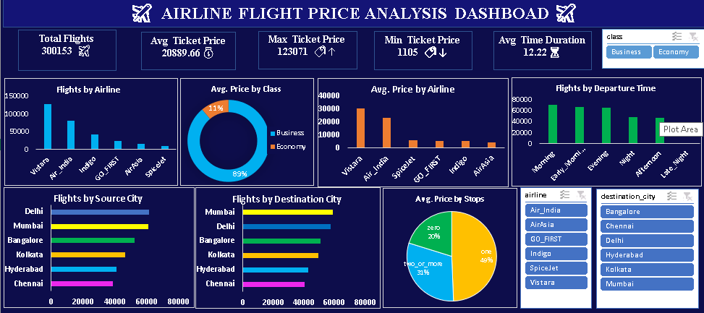
Figure 1. Submitted Microsoft Excel Airline Flight Price Analysis Dashboard

6.1 Excel Dashboard Components
Dashboard Area | Purpose
Total Flights | Shows the overall number of flight records.
Avg. Ticket Price | Shows the overall average ticket price.
Max Ticket Price | Shows the highest ticket price in the dataset.
Min Ticket Price | Shows the lowest ticket price in the dataset.
Avg. Time Duration | Shows the overall average flight duration.
Flights by Airline | Compares flight volume across airlines.
Avg. Price by Class | Shows the price/class distribution used in the dashboard.
Avg. Price by Airline | Compares average price across airlines.
Flights by Departure Time | Compares flight volume by departure-time category.
Flights by Source/Destination City | Compares city-level flight volumes.
Avg. Price by Stops | Compares price across stop categories.
Filters | Allows dashboard users to focus on selected categories.

7. Power BI Dashboard Analysis
The submitted Power BI dashboard presents the same analytical themes in an interactive business-intelligence layout. The dashboard emphasizes KPI cards and horizontal/vertical bar charts for quick comparison, with slicers for Airline, Class, Destination City, Departure Time, and Stops.
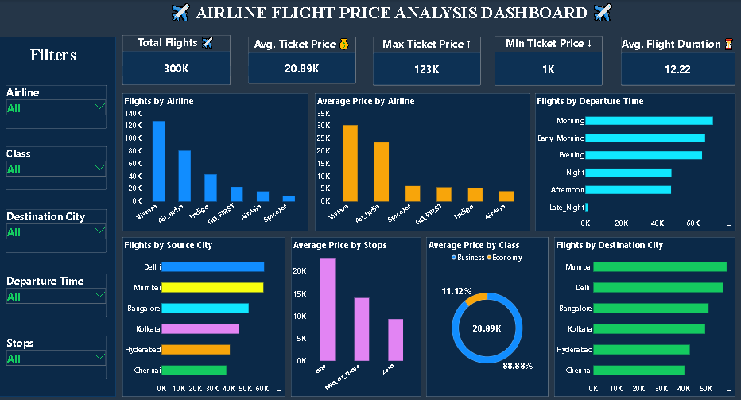
Figure 2. Submitted Power BI Airline Flight Price Analysis Dashboard

7.1 Power BI KPI Summary
KPI | Displayed Value
Total Flights | 300K / 300,153
Avg. Ticket Price | 20.89K / approximately 20,890
Max Ticket Price | 123K / 123,071
Min Ticket Price | 1K / 1,105
Avg. Flight Duration | 12.22

7.2 Power BI Visuals and Interpretation
- Flights by Airline clearly shows Vistara as the largest record category, followed by Air India and Indigo.
- Average Price by Airline shows visible differences among airlines, with Vistara at the highest level in the submitted dashboard.
- Flights by Departure Time shows Morning as the largest departure-time category in the displayed dashboard.
- Flights by Source City compares Delhi, Mumbai, Bangalore, Kolkata, Hyderabad, and Chennai.
- Average Price by Stops compares one, zero, and two_or_more stop categories.
- Average Price by Class provides a class-level price view, while Total Flights by Class shows the much larger Economy segment.
- The slicers allow users to filter the dashboard by Airline, Class, Destination City, Departure Time, and Stops.

8. Tableau Dashboard Analysis
The Tableau dashboard provides another presentation of the same flight-price analysis. Its layout emphasizes horizontal comparisons and interactive filters while retaining the project's major KPIs.
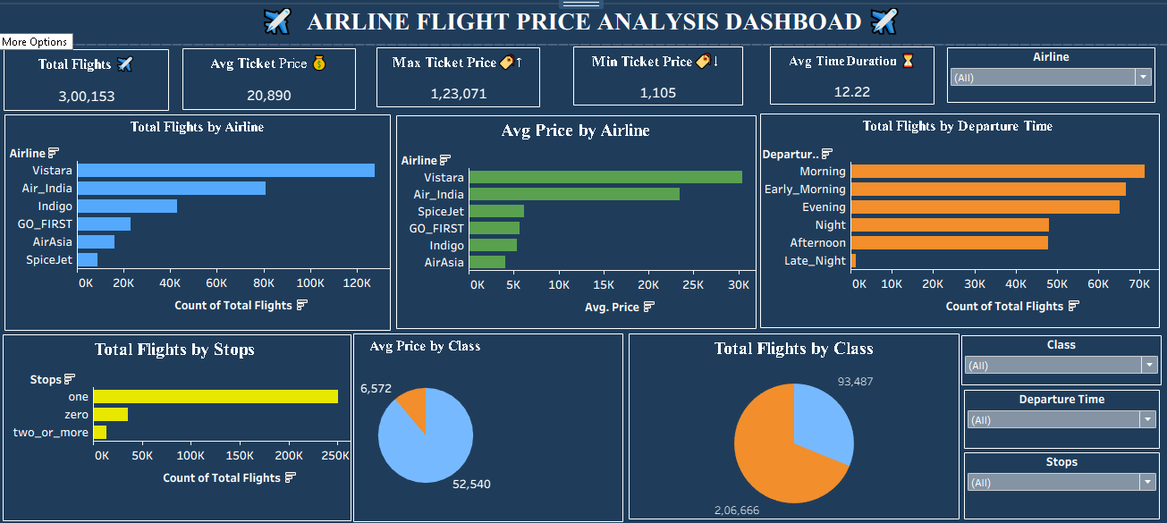
Figure 3. Submitted Tableau Airline Flight Price Analysis Dashboard

8.1 Tableau Visual Components
Visualization | Analytical Purpose
Total Flights by Airline | Compare airline-level flight volume.
Avg. Price by Airline | Compare average ticket price across airlines.
Total Flights by Departure Time | Compare volume by departure-time category.
Total Flights by Stops | Understand the distribution of stop categories.
Avg Price by Class | Show class-level price distribution.
Total Flights by Class | Show Business vs Economy record volume.
Airline / Class / Departure Time / Stops Filters | Enable interactive slicing of the dashboard.

8.2 Tableau Observations
- The airline-volume pattern is consistent with the EDA and Power BI views: Vistara has the largest number of records.
- The average-price chart shows Vistara at the highest displayed average price among the airlines.
- The departure-time chart shows Morning as the largest displayed category.
- The stops chart is strongly concentrated in the one-stop category.
- The class chart shows Economy as the larger flight-volume segment, consistent with the EDA class counts.

9. Cross-Platform Comparison
The three dashboard implementations communicate the same core dataset from different analytical perspectives. The underlying EDA provides the statistical foundation, while Excel, Power BI, and Tableau provide increasingly interactive ways to communicate the results.
Aspect | EDA / Python | Excel | Power BI | Tableau
Primary purpose | Explore and validate | Spreadsheet reporting | Interactive BI | Interactive visual analytics
Data quality checks | Strong | Limited in dashboard view | Model/report dependent | Model/report dependent
Statistical analysis | Strong | Moderate | Moderate | Moderate
Interactive filters | Notebook-driven | Dashboard filters | Slicers | Filters
KPI presentation | Code/output based | Strong | Strong | Strong
Visual exploration | Strong for custom EDA | Moderate | Strong | Strong
Best demonstrated use | Discovery | Compact reporting | Business dashboarding | Interactive visual storytelling

10. Key Findings
- The dataset contains 300,153 flight records and 12 columns.
- No missing values were found in the submitted EDA checks.
- No duplicate rows were found in the submitted EDA checks.
- Average ticket price is 20,889.66, with a minimum of 1,105 and a maximum of 123,071.
- Average flight duration is approximately 12.22 hours, with a range from 0.83 to 49.83 hours.
- Vistara has the largest number of records (127,859), followed by Air India (80,892) and Indigo (43,120).
- Economy class contains 206,666 records, while Business class contains 93,487 records.
- One-stop flights form the dominant stops category in the dashboard views.
- The submitted dashboards show visible variation in average ticket price across airlines.
- Morning is the largest displayed departure-time category in the dashboard outputs.
- Flight duration and days left were specifically examined against price through scatter plots in the EDA.

11. Business Interpretation
The analysis can support several practical analytical questions for an airline or travel-analysis context. The airline distribution helps identify where the dataset is concentrated. Price-by-airline and price-by-class views support comparative pricing analysis. Departure-time and stops analysis can be used to understand how itinerary structure and scheduling categories are represented in the data. Source and destination city views support route-level exploration.
The EDA scatter plots for duration versus price and days-left versus price provide a foundation for deeper statistical or machine-learning analysis. These relationships should be quantified with appropriate statistical measures or models before making causal claims.

12. Limitations and Data Considerations
- The report is based on the submitted EDA notebook and dashboard screenshots; the original source data file itself was not supplied as a separate current attachment.
- Some dashboard labels use abbreviated values such as K, while the EDA provides exact descriptive-statistic values.
- The notebook's 'Average Price by Class' visualization is implemented as a distribution plot; the dashboard implementations present class-level price summaries differently.
- The analysis describes observed patterns in the dataset and does not establish causal relationships between variables.
- The dashboards are descriptive; further predictive modeling would be required to forecast ticket prices.

13. Suggested Next Steps
- Create a formal data dictionary for all 12 variables.
- Standardize categorical labels and verify business definitions for departure time, arrival time, and stops.
- Add a detailed price analysis by airline × class × stops × days_left.
- Quantify the relationship between days_left and price using correlation and regression analysis.
- Build a predictive model for ticket price after appropriate feature engineering.
- Add route-level analysis using source city and destination city combinations.
- Add a time-series component if actual booking/travel dates become available.
- Create a unified dashboard theme and consistent number formatting across Excel, Power BI, and Tableau.

14. Conclusion
The Airline Flight Price Analysis project demonstrates a complete data-analysis workflow from exploratory analysis to dashboard-based communication. The EDA establishes data quality and descriptive findings, while Excel, Power BI, and Tableau translate those findings into visual reports for different reporting environments.
The analysis identifies the overall scale of the dataset, the distribution of airlines and travel classes, ticket-price range, average duration, departure-time patterns, stop categories, and city-level flight volumes. The consistency of the major patterns across the submitted outputs makes the project suitable as a practical demonstration of data analysis and business intelligence techniques.

